FOR IMMEDIATE RELEASE
Billiard Accessory Manufacturer CUE CUBE Introduces Dime Profile Shaper/Scuffer
Plymouth, WI – November 7, 2017 - Cue Cube, LLC, manufacturer of the original pool cue shaper and scuffer, is introducing a new shape Cue Cube®. The new profile is a US dime radius - .358” or 8.96 mm.

The dime Cue Cube was developed after many requests from retailers who have had inquiries from their customers. Some players prefer at tighter tip radius on their cue. Offered in the three most popular colors (silver, blue and black), the product also features a new label designed to differentiate the existing nickel and new dime products. As the product is distributed internationally, the label specifically calls out the radius in both inches and millimeters. Suggested retail prices are $9.95 for the silver cube and $10.95 for the blue and black versions.
Like many billiards accessories, the Cue Cube® was originally developed by someone who wanted a tool for themselves. Established in Milwaukee, Wisconsin in 1982, the company took their cue from professional pool players to make product improvements and launch the Shaft Slicker® several years later.
All products are made in Wisconsin using high quality materials and manufacturing processes, and “MADE IN U.S.A.” is proudly printed on every product. For more information on Cue Cube and Shaft Slicker products, please visit www.cuecube.com or send a request to info@cuecube.com.

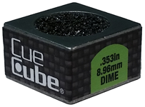
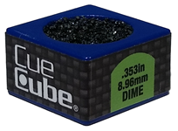
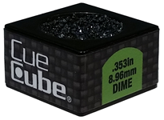

#91153 Silver Dime Cue Cube #91174 Blue Dime Cue Cube #91173 Black Dime Cue Cube
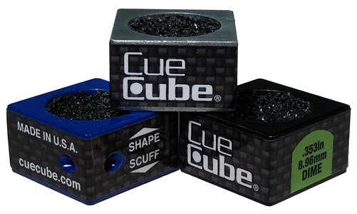

Group Image – All Three Colors

